CUSTOMER RETENTION & CHURN ANALYSIS
Future Interns – Data Science & Analytics Task 2
Prepared By
D.Monika
Internship Program
Future Interns – Data Science & Analytics
Tools Used
- Microsoft Power BI
- Microsoft Excel
Dataset
Telco Customer Churn Dataset
Submission Date
18 June 2026

1. Introduction
Customer retention is a critical factor in the success of subscription-based businesses. Retaining existing customers is often more cost-effective than acquiring new ones, making customer churn analysis an important aspect of business intelligence and strategic decision-making.
Customer churn refers to the percentage of customers who discontinue a service within a given period. By analyzing churn behavior, organizations can identify risk factors, improve customer satisfaction, and implement strategies to reduce customer attrition.
This project focuses on analyzing customer retention and churn patterns using the Telco Customer Churn dataset. The analysis was performed using Microsoft Power BI to identify trends, visualize customer behavior, and provide actionable recommendations for improving customer retention.

2. Task Description
As part of Future Interns Data Science & Analytics Task 2, the objective was to perform Customer Retention and Churn Analysis using customer subscription data.
The purpose of this task was to understand why customers leave a service and identify the factors that contribute to customer retention. This type of analysis is commonly used in SaaS companies, subscription-based businesses, and technology organizations where customer retention directly affects revenue and growth.
The task involved:
- Cleaning and preparing customer data
- Analyzing churn rates and retention trends
- Identifying customer segments with high churn risk
- Creating business-focused visualizations
- Developing recommendations to improve customer retention
The final deliverable consisted of a Power BI dashboard and a business analytics report presenting key findings and recommendations.

3. Project Objectives
The primary objectives of this project were:
- Measure overall customer churn and retention rates
- Identify customer groups with the highest churn levels
- Analyze churn behavior across different contract types
- Evaluate the relationship between internet services and customer retention
- Generate actionable business recommendations
- Develop an interactive Power BI dashboard for decision-making

4. Dataset Overview
The Telco Customer Churn dataset contains customer demographic information, subscribed services, account details, and churn status.
Dataset Summary
Attribute | Value
Total Records | 7,043
Total Columns | 21
Analysis Tool | Microsoft Power BI
Target Variable | Churn (Yes/No)
Key Variables
The dataset includes:
- Customer ID
- Gender
- Senior Citizen Status
- Partner
- Dependents
- Tenure
- Internet Service
- Contract Type
- Payment Method
- Monthly Charges
- Total Charges
- Churn Status
These variables provide valuable insights into customer behavior and retention patterns.

5. Data Cleaning and Preparation
Before conducting the analysis, the dataset underwent several preprocessing steps to ensure data quality and consistency.
Data Preparation Process
- Imported the dataset into Power BI.
- Verified column data types.
- Identified missing and blank values.
- Cleaned the Total Charges column.
- Removed invalid records where necessary.
- Checked data consistency across categorical variables.
- Prepared the dataset for visualization and dashboard development.
Proper data preparation is essential to ensure accurate analysis and reliable business insights.

6. Dashboard Development
A Power BI dashboard was created to analyze customer retention and churn behavior.
The dashboard includes:
KPI Metrics
- Total Customers
- Churn Customers
- Churn Rate
Visualizations
- Churn by Contract Type
- Churn by Internet Service
- Customer Churn Distribution
These visualizations help stakeholders understand customer behavior and identify factors contributing to customer churn.

7. Dashboard Visualizations and Analysis
7.1 Overall Dashboard
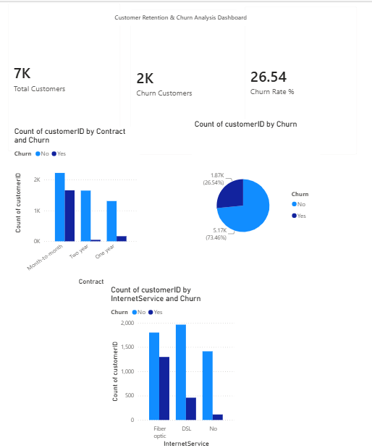
Figure 1: Customer Retention & Churn Analysis Dashboard
The dashboard provides a comprehensive overview of customer churn trends, retention metrics, and customer behavior patterns. It enables quick identification of high-risk customer segments and supports data-driven decision-making.

7.2 KPI Summary
The dashboard revealed the following key metrics:
- Total Customers: 7,043
- Churn Customers: 1,869
- Churn Rate: 26.54%
These indicators provide a high-level overview of customer retention performance and overall business health.

7.3 Churn by Contract Type
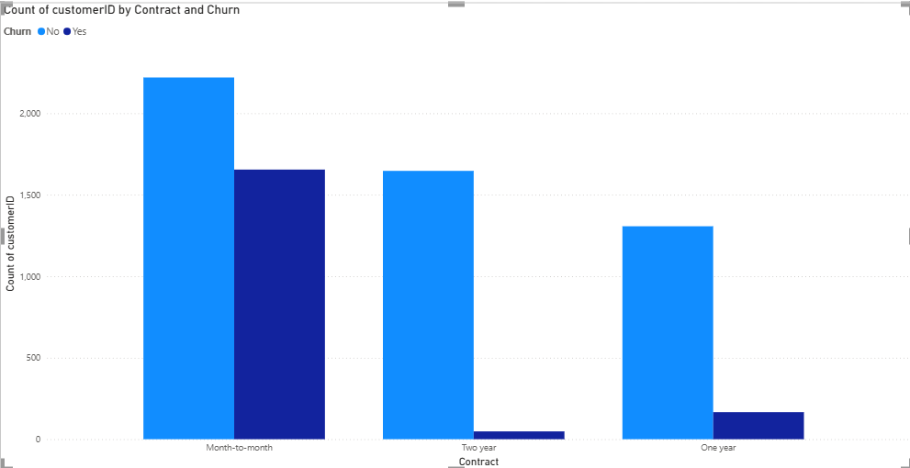
Figure 2: Customer Churn by Contract Type
Analysis
The visualization shows customer churn across different contract types. Customers with Month-to-Month contracts account for the highest number of churn cases.
In contrast, customers subscribed to One-Year and Two-Year contracts demonstrate significantly lower churn levels.
Business Insight
Long-term contracts contribute to stronger customer loyalty and higher retention rates. Customers who commit to longer contract periods are less likely to discontinue the service.

7.4 Churn by Internet Service
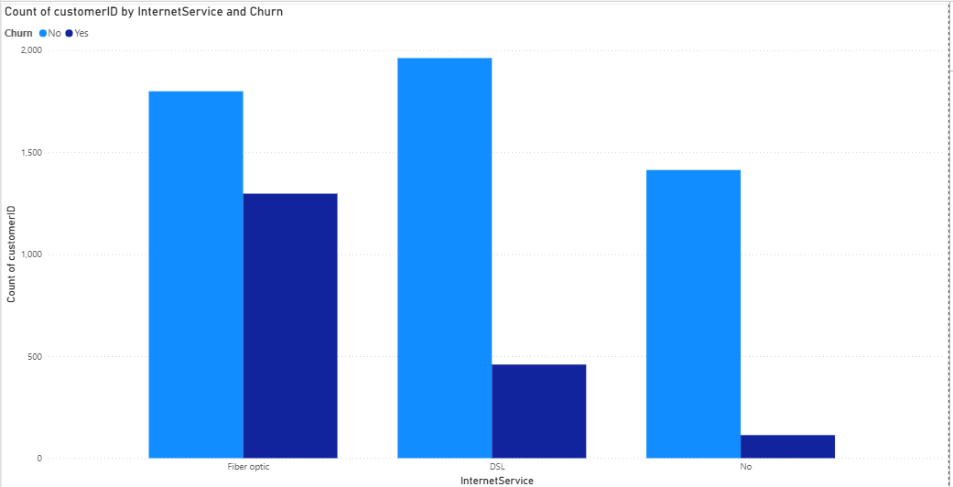
Figure 3: Customer Churn by Internet Service
Analysis
The chart indicates that Fiber Optic customers experience the highest churn levels compared to DSL users and customers without internet services.
Business Insight
Fiber Optic customers may have higher expectations regarding service quality, pricing, and support. Improving the customer experience for this segment may significantly reduce churn.

7.5 Customer Churn Distribution
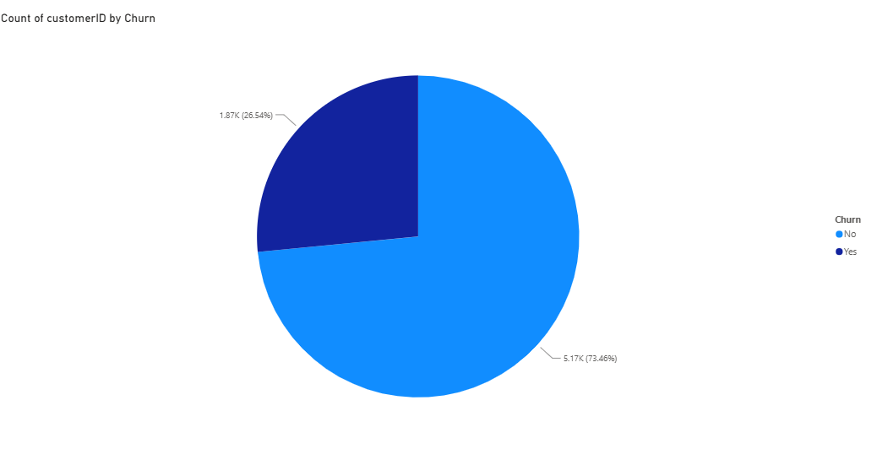
Figure 4: Overall Customer Churn Distribution
Analysis
The pie chart illustrates the proportion of customers who churned compared to those who remained active.
The analysis shows that approximately 26.54% of customers have churned, while the majority remain active customers.
Business Insight
Although retention levels remain relatively strong, the churn percentage represents a significant opportunity for business improvement.

8. Key Findings
Finding 1
The overall customer churn rate is approximately 26.54%, indicating that more than one-quarter of customers discontinued the service.
Finding 2
Customers subscribed to Month-to-Month contracts exhibit the highest churn levels among all contract categories.
Finding 3
Fiber Optic customers experience higher churn rates compared to DSL users and customers without internet services.
Finding 4
Long-term contract customers demonstrate significantly stronger retention behavior.
Finding 5
Customer retention can be improved through targeted engagement strategies and loyalty initiatives.

9. Recommendations
1. Encourage Long-Term Contracts
Offer discounts, rewards, and loyalty benefits to encourage customers to transition from Month-to-Month contracts to annual plans.
2. Improve Fiber Optic Customer Experience
Enhance service quality, strengthen technical support, and collect customer feedback to address the concerns of Fiber Optic subscribers.
3. Implement Targeted Retention Campaigns
Identify high-risk customer segments and provide personalized offers designed to improve retention.
4. Develop Customer Loyalty Programs
Reward long-term customers with exclusive benefits and incentives to increase satisfaction and reduce churn.
5. Monitor Churn Trends Continuously
Utilize business intelligence dashboards to regularly track customer behavior and evaluate the effectiveness of retention strategies.

10. Conclusion
This project successfully analyzed customer retention and churn behavior using the Telco Customer Churn dataset and Microsoft Power BI.
The findings indicate that contract type and internet service play a significant role in influencing customer churn. Customers on Month-to-Month contracts and Fiber Optic services demonstrate a higher tendency to leave the service.
By implementing data-driven retention strategies, businesses can improve customer satisfaction, reduce churn rates, and enhance long-term profitability.
This project demonstrates the practical application of data analytics, business intelligence, and visualization techniques in solving real-world business challenges.

11. Skills Demonstrated
- Data Cleaning and Preparation
- Data Visualization
- Power BI Dashboard Development
- Customer Retention Analysis
- Customer Churn Analysis
- Business Intelligence
- Insight Generation
- Data-Driven Decision Making

12. References
Telco Customer Churn Dataset
Source:
https://www.kaggle.com/datasets/blastchar/telco-customer-churn
Microsoft Power BI Documentation
Future Interns – Data Science & Analytics Task 2 Guidelines

